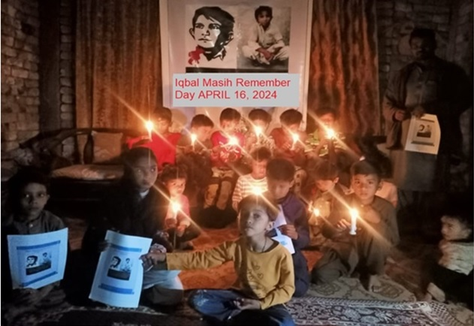

**Iqbal Masih Foundation**